# Role tITLE: Building Surveyor

# 

# Department: children’s

# 

# Reports to: principal surveyor

# 

# Grade: PO2

# Responsible for: N/A

# ______________________________________________________________________________

# ROLE DESCRIPTION

1. To participate as a member of the Surveyor Team to undertake a wide range of building surveying and related project management duties.

2. You will be the ‘link surveyor’ for a group of schools and other buildings. You will proactively engage with school headteachers, business managers, site managers contractors, consultants building control, planning and health & safety to effectively deliver planned and urgent works.

3. To contribute to the development of an asset management function for Children’s Department assets, including delivery of special projects and initiatives and helping maintain relevant project management, financial and other systems.

# ABOUT THE ROLE

You will need to:

* Assess condition issues and identify practical solutions.
* Assist with managing reactive schemes of work to schools and other corporate properties
* Develop and reviewing agreed programmes of planned maintenance work with individual schools, accurately assessing both condition and urgency of works and estimating costs.
* Assist in developing specifications for quotes and ITTs.
* Assist in evaluating bids.
* Project manage consultants and contractors throughout all RIBA Design stages including the delivery of works
* Contribute to the development and delivery of major capital works.
* Contribute to the development of bids for external funding
* Help maintain project management, financial and other relevant systems and databases.
* Undertake other duties commensurate with the grade
* Ensure your actions and decisions align with the Council’s declaration of a climate and ecological emergency.
* Assist with managing planning applications and listed building applications predominantly undertaken by external consultants.
* Be able to assist procuring works, i.e; working with frameworks and complying with internal procedures to tender works

# ABOUT YOU

Knowledge & Skills:

* You will have a degree in building surveying or similar relevant experience.
* Excellent interpersonal skills
* Excellent verbal and written communication skills.
* Familiarity with MS Office products such as Word and Excel.

# ABOUT US

How we act defines who we are. At the heart of our organisation is a common approach to defining ‘who we are’. We are looking for people that can build this into everything they do.

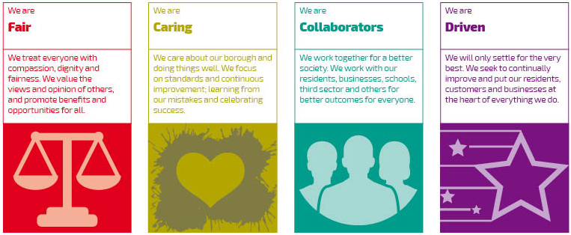

# Corporate requirements

# Civil and Other Emergencies

To support the Council’s role in planning for and responding to civil and council emergencies using skills/expertise of the post holder, and in accordance with council emergency procedures. To provide emergency contact details for the purposes of emergency and service continuity plans. To ensure that you have read your Service’s business continuity plan and keep abreast of any updates, so that you know what to do, if the plan is activated. To participate in any testing of emergency plans, as directed and take an active role in making suggestions to improve team plans.

# Digital

To use the Council’s office-based and mobile IT services for the input, access and transmission of information using the appropriate level of information security and classification through the use of electronic mail, diaries, word-processing, spreadsheets and databases as well as any specific job-related applications as required to carry out the duties of the post.

# Information Management

To comply with information rights legislation and the Council’s data quality and information management standards by applying information management related policies.

To report instances of non-compliance, errors, omissions or inadequacies in procedures to the business unit manager.

# Health and Safety

To take reasonable care for his/her own health and safety and any other person(s) who may be affected by his/her acts or omissions at work, in accordance with the Health & Safety legislation.

To co-operate with the Council insofar as is necessary to enable it to comply with its duties under relevant health and safety legislation.

# Agile working

H&F prides itself on being an agile workforce and promotes flexible working opportunities.

# Safeguarding of Children, Young People and Adults (for all front-line staff in Children’s Services and Adult Social Care)

To be aware of and work in accordance with the Council’s child and adult protection policies and procedures in order to safeguard and promote the welfare of children and adults and to raise any concerns relating to such procedures which may be noted during the course of duty.

For further information on whether a Standard or Enhanced Disclosure check is required, managers should refer to Disclosure and Barring Scheme guidance

# CLIMATE AND ECOLOGICAL EMERGENCY

To ensure compliance with the Council’s low-carbon culture, for which climate and ecological literacy training is provided, along with an advice service from the council’s climate team.

To ensure decision making, actions and day-to-day choices align with the Council’s declaration of a climate and ecological emergency.

# Equity Diversity and Inclusion Statement

We’re committed to making Hammersmith & Fulham one of the most inclusive borough’s in the country; a place where everyone feels valued, included and has equitable access to opportunities.

Hammersmith and Fulham is an inclusive employer and welcomes applications from all sections of the community. We work to eradicate discrimination on the basis of race, religion, gender, gender identity, sexual orientation, disability, pregnancy and maternity, age and marital status. We also recognise that people can be disadvantaged by their social and economic circumstances, so we will also work to eliminate discrimination and disadvantage caused by social class.

We will be pleased to consider applications from candidates seeking flexible working arrangements.

As users of the disability confident scheme, we guarantee to interview all disabled applicants who meet the minimum criteria for the advertised role.